M3. Assignment 4.3 SQL Rossler Gian Karlo Boquiren

1. STORED FUNCTION: count_backwards

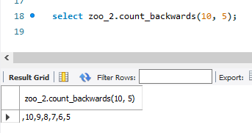

1. STORED FUNCTION: count_funny  
     
   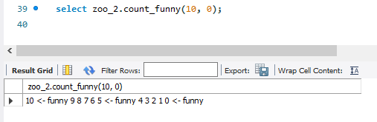
2. STORED FUNCTION: my_birthday

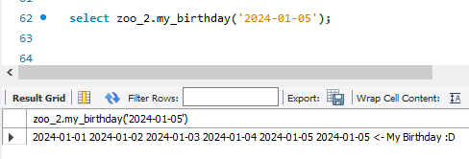

1. Create a function that retrieves the animal’s id and returns its price.  
     
   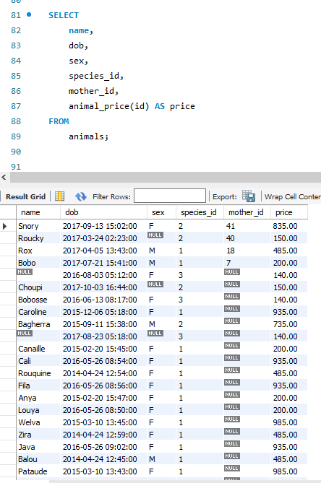
2. Add a new column to the "species" table to show the count of each species number found in the "animal" table by utilizing the "count_species" function and inserting the appropriate values.  
   Then create a trigger that updates this column each time a record is inserted into the "animal" table. To test it insert a new record in animal table.  
     
   